NYSSLS Daily Lesson Plan
Instructional Unit: Geologic History – The cycling of carbon among the hydrosphere, atmosphere, geosphere, and biosphere |  |  |  |  | Period(s) of Unit: |  |  | Date:
Materials/Resources/Links:  2024 Edition – Earth and Space Science Reference Tables  earth_space_science_ref_tables_2024.pdf (nysed.gov)  https://www.youtube.com/watch?v=A4cPmHGegKI  https://www.un.org/en/climatechange/what-is-climate-change |  |  |  |  |  |  |  | Course: Earth and Space Science
Special Notes for Lesson:
- Interdisciplinary Connections
  - Biology
    - Photosynthesis and Respiration: Understanding the biological processes of photosynthesis and respiration and their roles in the carbon cycle.
    - Ecology: Exploring ecosystems and the role of decomposers, producers, and consumers in the carbon cycle.
  - Chemistry
    - Chemical Reactions: Studying the chemical reactions involved in the formation and breakdown of carbon compounds.
    - Carbon Compounds: Understanding organic and inorganic carbon compounds, including CO₂, CH₄ (methane), and carbonates.
  - Environmental Science
    - Climate Change: Investigating the impact of carbon cycle disruptions on climate change.
    - Human Impact: Exploring human activities such as deforestation and fossil fuel combustion and their effects on the carbon cycle.
  - Geography
    - Earth Systems: Understanding the geographical distribution of carbon reservoirs and the movement of carbon through different Earth systems.
    - Environmental Policy: Examining how geographic factors influence environmental policies related to carbon management.
  - Mathematics
    - Data Analysis: Using mathematical tools to analyze data on carbon levels in different reservoirs.
    - Modeling: Developing quantitative models to predict changes in carbon levels and their effects on Earth systems.
- Scientific Skills Emphasis
  - Developing and Using Models
    - Create and interpret quantitative models of the carbon cycle.
    - Use simulations to predict effects of carbon level changes.
  - Analyzing and Interpreting Data
    - Collect and analyze data on carbon emissions and fluxes.
    - Interpret graphs showing changes in carbon levels over time.
  - Constructing Explanations and Designing Solutions
    - Explain carbon movement through Earth systems.
    - Design solutions to mitigate human impact on the carbon cycle.
  - Engaging in Argument from Evidence
    - Use evidence to discuss and debate carbon cycle impacts.
    - Evaluate claims related to carbon cycling and policy.
Prior Knowledge to Review
- Basic Biology
  - Photosynthesis: Understanding how plants convert CO₂ and water into glucose and oxygen using sunlight.
  - Respiration: Understanding how organisms convert glucose and oxygen into energy, releasing CO2 and water.
- Basic Chemistry
  - Chemical Reactions: Familiarity with chemical equations, particularly those involving carbon compounds.
  - Carbon Compounds: Basic knowledge of organic and inorganic carbon compounds (CO2, methane, carbonates).
- Earth Science
  - Earth's Spheres: Understanding the components of the hydrosphere, atmosphere, geosphere, and biosphere.
  - Biogeochemical Cycles: Basic knowledge of how elements cycle through different Earth systems.
- Environmental Science
  - Human Impact: Awareness of how human activities like deforestation and fossil fuel combustion affect the environment.
  - Climate Change: Basic understanding of the greenhouse effect and global warming.
Anchoring Phenomenon: https://www.youtube.com/watch?v=A4cPmHGegKI
What exactly is the carbon cycle? Nathaniel Manning provides a basic look into the cyclical relationship of carbon, humans and the environment.
- The video suggests that the solution to climate change is “the limitless potential of creative people to build un-imagined technologies.” Do you feel that people inventing sustainable technologies can solve climate change? Explain why or why not you think this is a logical conclusion.
Standards: HS-ESS2-6
. Earth’s Systems Develop a quantitative model to describe the cycling of carbon among the hydrosphere, atmosphere, geosphere, and biosphere.
Science and Engineering Practices  Developing and Using Models  - Develop a model based on evidence to illustrate the relationships between systems or between components of a system. |  | Disciplinary Core Idea(s)  ESS2.D: Weather & Climate  - Gradual atmospheric changes were due to plants and other organisms that captured carbon dioxide and released oxygen.  - Changes in the atmosphere due to human activity have increased carbon dioxide concentrations and thus affect climate. |  |  |  |  | Cross Cutting Concepts  Energy and Matter  - The total amount of energy and matter in closed systems is conserved.
Performance Level
NYS Level 5 | NYS Level 4 |  | NYS Level 3 |  |  | NYS Level 2 |  |  | NYS Level 1
Develop and analyze data from a quantitative model of the carbon cycle to predict how a change in carbon levels in one system will affect other Earth systems. | Develop a quantitative model to describe the cycling of carbon among the hydrosphere, atmosphere, geosphere, and biosphere. |  | Use/complete a quantitative model to describe the cycling of carbon between two Earth spheres (hydrosphere, atmosphere, geosphere, and biosphere). |  |  | Use a quantitative/ qualitative model to identify the cycling of carbon between two Earth spheres (hydrosphere, atmosphere, geosphere, and biosphere). |  |  | Use a quantitative/ qualitative model that shows the cycling of carbon between two Earth spheres to identify the relative concentrations of carbon present in each sphere.
Clarification Statement  Emphasis is on modeling biogeochemical cycles that include the cycling of carbon through the ocean, atmosphere, soil, and biosphere (including humans), providing the foundation for living organisms. |  |  |  | Assessment Boundary
Connection to Anchoring Phenomenon:
- Describe how industrial activities, deforestation, and fossil fuel combustion have disrupted the natural carbon cycle.
- Present case studies of existing sustainable technologies and their impact on reducing carbon emissions. Discuss both the successes and challenges faced by these technologies.
- Conclude by emphasizing the importance of creativity and innovation in solving global challenges. Encourage students to think about how they can contribute to sustainable solutions in their future careers.
Essential Question(s):
- How does carbon move between the hydrosphere, atmosphere, geosphere, and biosphere, and what processes are involved in these transfers?
  - This question aims to help students identify and understand the different pathways and processes involved in the carbon cycle, such as photosynthesis, respiration, decomposition, and combustion.
- What are the relative concentrations of carbon in the hydrosphere, atmosphere, geosphere, and biosphere, and how do these concentrations impact the overall carbon cycle?
  - Students will explore the distribution of carbon across different Earth systems and the implications of these concentrations on the carbon cycle.
- How can we develop a quantitative model to accurately describe the cycling of carbon among the different Earth systems?
  - This question encourages students to think critically about the components and structure of a quantitative model that represents the carbon cycle, including the variables and equations needed.
- How might changes in one part of the carbon cycle, such as increased atmospheric CO2 levels, affect other parts of the system, such as ocean acidification or soil carbon content?
  - Students will analyze the interconnectedness of Earth systems and predict the consequences of changes in carbon levels within one system on the others.
- In what ways do human activities influence the carbon cycle, and how can we model these impacts to predict future environmental changes?
  - This question focuses on the anthropogenic effects on the carbon cycle, such as fossil fuel combustion and deforestation, and the importance of modeling these impacts for environmental prediction and management.
Instructional Strategies & Learning Tasks: Engage, Explore, Explain, Elaborate, Evaluate
Engage: Anchoring phenomenon, demonstration; observations of images, video clip or data… |  | Objective: Activate students' prior knowledge and pique their interest in the carbon cycle.  Activity: Show an engaging video clip about the carbon cycle.  Video Resource: https://www.youtube.com/watch?v=A4cPmHGegKI  Discussion Questions:  - The video suggests that the solution to climate change is “the limitless potential of creative people to build un-imagined technologies.” Do you feel that people inventing sustainable technologies can solve climate change? Explain why or why not you think this is a logical conclusion.
Explore: Students investigate, experiment, hands-on activity…. |  | Objective: Students will investigate how carbon moves between different spheres of the Earth.  Activity: PhET Interactive Simulations' "The Greenhouse Effect"  Instructions: Students will use the PhET Interactive Simulations' "The Greenhouse Effect" to explore how carbon moves through these different spheres and observe the effects of various changes. By manipulating factors such as carbon emissions and deforestation, students will gain insight into the delicate balance of the carbon cycle and the role we play in maintaining it.  Guiding Questions:  - How do human activities, such as burning fossil fuels and deforestation, impact the levels of carbon in the atmosphere, and what are the potential consequences for Earth's climate?  - What role do plants and trees play in the carbon cycle, and how does increasing or decreasing vegetation affect the balance of carbon among the different Earth spheres (atmosphere, hydrosphere, geosphere, biosphere)?  - How do changes in one part of the carbon cycle (such as an increase in atmospheric carbon dioxide) influence other parts of the cycle, and what feedback mechanisms might help to stabilize or amplify these changes?
Explain: Students share their observations and evidence to explain their understanding…possible whole group/class discussion… |  | Objective: Facilitate understanding through teacher-led instruction.  Activity: Teacher lecture to explain the carbon cycle with the use of a detailed diagram of the carbon cycle. Explain each part of the cycle step-by-step, using clear and simple language.  Topics to be highlighted:  - Photosynthesis and Respiration  - Decomposition and Fossil Fuels  - Carbon Exchange Between Spheres
Elaborate: Students apply the science concepts they’ve just learned… |  | Objective: Assess students’ understanding and ability to explain the carbon cycle through a small group activity.  Activity: Each group will draw the carbon cycle, labeling the key processes (photosynthesis, respiration, decomposition, combustion, ocean uptake, sedimentation, volcanic activity).  - Each group will read their scenario card and discuss how the given scenario affects the carbon levels in each sphere. They should draw arrows or use symbols to show these changes on their diagram.  - Groups should prepare a brief explanation of their diagram and analysis to share with the class. Each group will present their diagram and explain how their scenario affects the carbon cycle.  Scenarios Examples:  - Increased Plant Growth: How does more vegetation affect the carbon cycle?  - Factory Emitting CO₂: How does increased industrial activity change carbon levels in the atmosphere?  - Deforestation: What happens when large areas of forest are cut down?  - Ocean Acidification: How does the increased absorption of CO₂ by the oceans affect marine life and carbon storage?  Assessment: Monitor groups during the activity to assess their understanding and participation.
Evaluate (Formative Assessment): Student learning is evaluated. |  | Objective: Assess students’ understanding and ability to explain the carbon cycle.  Assessment:  - Quiz: Provide a short, simple quiz with multiple-choice and fill-in-the-blank questions about the carbon cycle.

Copy and paste student worksheets below:

Application of Terms in Performance Levels
- Level 5: Students should be able to use data from models to predict the impacts of changes in carbon levels across different Earth systems.
- Level 4: Students should be able to develop their own quantitative models to describe carbon cycling among all four spheres.
- Level 3: Students should be able to use or complete existing models to describe carbon cycling between two spheres.
- Level 2: Students should be able to identify carbon cycling between two spheres using either quantitative or qualitative models.
- Level 1: Students should be able to identify relative concentrations of carbon in two spheres using either quantitative or qualitative models.

Core Objectives
- Understand the carbon cycle and its components.
- Develop and analyze quantitative models describing carbon fluxes among Earth's systems.
- Predict the impact of changes in carbon levels on different Earth systems.

Topic Breakdown
- Introduction to Earth's Systems
  - Overview of the hydrosphere, atmosphere, geosphere, and biosphere.
  - Interactions between Earth's systems.
- The Carbon Cycle
  - Detailed examination of carbon reservoirs (e.g., ocean, atmosphere, soil, biosphere).
  - Processes involved in carbon cycling (e.g., photosynthesis, respiration, decomposition).
- Quantitative Modeling of the Carbon Cycle
  - Developing models to represent carbon fluxes.
  - Analyzing data to predict changes in carbon levels.
- Impact of Carbon Changes on Earth Systems
  - Case studies and scenarios.
  - Predicting environmental and ecological impacts.

Teaching Methods
- Interactive Discussions: Engage students in discussions about carbon cycling processes.
- Modeling Exercises: Hands-on activities to develop and analyze quantitative models of the carbon cycle.
- Data Analysis: Use real-world data to predict the impact of changes in carbon levels.
- Group Projects: Collaborative projects to create and present models of the carbon cycle.

Assessment Strategies
- Quizzes: Assess understanding of carbon cycle components and processes.
- Research Projects: Students develop and present detailed models of the carbon cycle.
- Oral Presentations: Present predictions based on quantitative models of carbon changes.
- Data Analysis Exercises: Analyze and interpret data related to carbon cycling.

Name: Geologic History
Date: Period: Earth and Space Science
Class Notes – The Carbon Cycle Explained
The carbon cycle describes how carbon atoms move through the Earth's systems: the atmosphere (air), hydrosphere (water), geosphere (land), and biosphere (living things). Let's break down each part of the cycle step-by-step.

Let's visualize a simplified version of the carbon cycle:
- Atmosphere: Carbon dioxide (CO₂) in the air
- Biosphere: Plants and animals
- Geosphere: Soil, rocks, and fossil fuels
- Hydrosphere: Oceans and other bodies of water

Imagine the carbon cycle as a loop where carbon atoms travel through these four spheres.

STEP-BY-STEP EXPLANATION
- Photosynthesis (Atmosphere to Biosphere)
  - Plants absorb CO₂: Plants take in carbon dioxide from the atmosphere during photosynthesis
  - Produce oxygen and glucose: Using sunlight, plants convert CO₂ and water into oxygen (O₂) and glucose (a sugar they use for energy)
- Respiration (Biosphere to Atmosphere)
  - Plants and animals breathe: Plants and animals release carbon dioxide back into the atmosphere when they breathe; this process is called respiration
- Decomposition (Biosphere to Geosphere)
  - Dead plants and animals decompose: When plants and animals die, decomposers like bacteria and fungi break them down
  - Release carbon: This process releases carbon into the soil, enriching it
- Fossil Fuels (Geosphere to Atmosphere)
  - Formation: Over millions of years, carbon in dead plants and animals can become fossil fuels (like coal, oil, and natural gas) under high pressure and heat
  - Combustion: When humans burn fossil fuels for energy, CO₂ is released back into the atmosphere
Class Notes – The Carbon Cycle Explained
- Ocean Uptake (Atmosphere to Hydrosphere)
  - CO₂ dissolves in water: Carbon dioxide from the atmosphere can dissolve into the oceans and other bodies of water
  - Marine life uses carbon: Marine plants (like algae) use CO₂ for photosynthesis, just like land plants
- Sedimentation (Hydrosphere to Geosphere)
  - Formation of sediments: Carbon can settle in ocean sediments and over long periods become part of the geosphere.
  - Limestone formation: Some of this carbon becomes limestone and other types of rock.
- Volcanic Activity (Geosphere to Atmosphere)
  - Eruptions release CO₂: Volcanoes can release carbon dioxide from the Earth's interior back into the atmosphere during eruptions

INTERCONNECTIONS OF THE SPHERES
- Atmosphere to Biosphere: Plants take in carbon dioxide for photosynthesis, linking the atmosphere and biosphere
- Biosphere to Geosphere: When plants and animals die, carbon is transferred to the soil and potentially becomes fossil fuels
- Geosphere to Atmosphere: Burning fossil fuels releases stored carbon back into the atmosphere
- Atmosphere to Hydrosphere: Oceans absorb CO₂ from the atmosphere, and marine life uses it for photosynthesis
- Hydrosphere to Geosphere: Carbon in the ocean can become part of ocean sediments, eventually forming rocks
- Geosphere to Atmosphere: Volcanic eruptions can release carbon dioxide from rocks back into the atmosphere

Name: Geologic History
Date: Period: Earth and Space Science
Let’s Review – Exploring the Carbon Cycle
KEY COMPONENTS AND PROCESSES
Component | Description | Role in Carbon Cycle
Atmosphere
Plants
Animals
Soil
Oceans
Fossil Fuels

Name: Geologic History
Date: Period: Earth and Space Science
Let’s Review – Exploring the Carbon Cycle
MAJOR PROCESSES
Process | Description | Carbon Flow
Photosynthesis
Respiration
Decomposition
Combustion
Diffusion

Name: Geologic History
Date: Period: Earth and Space Science
Let’s Review – Exploring the Carbon Cycle
HUMAN IMPACTS
Human Activity | Description | Impact on Carbon Cycle
Fossil Fuel Combustion
Deforestation
Industrial Processes
Land Use Changes

Let’s Review – Exploring the Carbon Cycle
KEY – KEY COMPONENTS AND PROCESSES
Component | Description | Role in Carbon Cycle
Atmosphere | Layer of gases surrounding Earth | Contains CO₂ which is used and released by various processes
Plants | Living organisms that perform photosynthesis | Absorb CO₂ for photosynthesis, release O₂
Animals | Living organisms that consume plants and other organisms | Release CO₂ through respiration
Soil | Upper layer of Earth's surface containing organic matter | Stores carbon from decomposed organisms
Oceans | Large bodies of saltwater covering Earth | Absorb CO₂ from the atmosphere, store and release carbon
Fossil Fuels | Deposits of organic material transformed into coal, oil, and natural gas | Release CO₂ when combusted
KEY – MAJOR PROCESSES
Process | Description | Carbon Flow
Photosynthesis | Process by which plants use sunlight to synthesize food from CO₂ and water | CO₂ (atmosphere) → Organic Carbon (plants)
Respiration | Process by which organisms convert organic material into energy, releasing CO₂ | Organic Carbon (organisms) → CO₂ (atmosphere)
Decomposition | Breakdown of dead organisms, returning nutrients to the soil | Organic Carbon (dead organisms) → CO₂/Organic Carbon (soil)
Combustion | Burning of fossil fuels and organic matter, releasing CO₂ | Carbon (fossil fuels/biomass) → CO₂ (atmosphere)
Diffusion | Movement of CO₂ between the atmosphere and the ocean | CO₂ (atmosphere) ↔ CO₂ (ocean)
KEY – HUMAN IMPACTS
Human Activity | Description | Impact on Carbon Cycle
Fossil Fuel Combustion | Burning of coal, oil, and natural gas for energy | Increases atmospheric CO₂ levels
Deforestation | Clearing forests for agriculture or urban development | Reduces CO₂ absorption by plants, increases atmospheric CO₂
Industrial Processes | Manufacturing and chemical processes releasing CO₂ | Increases atmospheric CO₂ levels
Land Use Changes | Conversion of natural landscapes for human use | Alters natural carbon storage and fluxes

Name: Geologic History
Date: Period: Earth and Space Science
Lab Activity – Exploring the Carbon Cycle
Lab #
INTRODUCTION:
The carbon cycle is a fundamental Earth system that regulates the flow of carbon among the atmosphere, hydrosphere, geosphere, and biosphere. Understanding this cycle is crucial for comprehending how human activities, such as burning fossil fuels and deforestation, impact our planet. In this lab, you will use the PhET Interactive Simulations' "The Greenhouse Effect" to explore how carbon moves through these different spheres and observe the effects of various changes. By manipulating factors such as carbon emissions and deforestation, you will gain insight into the delicate balance of the carbon cycle and the role we play in maintaining it.

OBJECTIVE:
Understand how carbon moves through the hydrosphere, atmosphere, geosphere, and biosphere by interacting with a carbon cycle simulation.

VOCABULARY:
Carbon Cycle:

Atmosphere:

Hydrosphere:

Geosphere:

Biosphere:

Carbon Emissions:

PhET INTERACTIVE SIMULATION:
https://phet.colorado.edu/en/simulations/greenhouse-effect/about
Lab Activity – Exploring the Carbon Cycle
HYPOTHESIS:
- Predict what will happen to the carbon levels in the atmosphere if carbon emissions increase.

- Predict how deforestation will affect the carbon levels in the biosphere and atmosphere.

- Predict the impact of planting more trees on carbon levels in the atmosphere and biosphere.

- Predict how increasing the use of fossil fuels will change carbon levels across all spheres.

IDENTIFYING COMPONENTS:
- Atmosphere
  - What is the role of the atmosphere in the carbon cycle?

  - List two ways carbon enters the atmosphere.
1.
2.

- Hydrosphere
  - How does carbon move into the hydrosphere?

  - List one process that transfers carbon from the hydrosphere to another sphere.

Lab Activity – Exploring the Carbon Cycle
- Geosphere
  - Explain how carbon is stored in the geosphere.

  - Name one way carbon is released from the geosphere.

- Biosphere
  - Describe the role of the biosphere in the carbon cycle.

  - Identify one way carbon is transferred from the biosphere to another sphere.

MANIPULATING VARIABLES:
- Increasing Carbon Emissions:
  - Use "The Greenhouse Effect" simulation to increase carbon emissions.
  - Observe and describe what happens to the carbon levels in the atmosphere.
- Deforestation:
  - Simulate deforestation effects on the biosphere in the context of greenhouse gases.
  - Note the changes in carbon levels in the biosphere and atmosphere.
- Planting Trees:
  - Add more trees or simulate an increase in photosynthesis in the biosphere.
  - Describe how this affects carbon levels in the atmosphere and biosphere.
- Fossil Fuel Use:
  - Simulate an increase in the use of fossil fuels.
  - Observe and record the changes in carbon levels across all spheres.

Lab Activity – Exploring the Carbon Cycle
DATA COLLECTION AND ANALYSIS:
- Use the table below to record your observations for each manipulation.
Manipulation | Atmosphere | Hydrosphere | Geosphere | Biosphere
Carbon Emissions
Deforestation
Planting Trees
Fossil Fuel Use

- Create a graph to visually represent the changes in carbon levels for each manipulation.
  - Use different colors or markers for each sphere (atmosphere, hydrosphere, geosphere, biosphere).

    - Red – Atmosphere
    - Blue – Hydrosphere
    - Green – Geosphere
    - Yellow – Biosphere

Carbon Levels in Different Earth Spheres under Various Manipulations
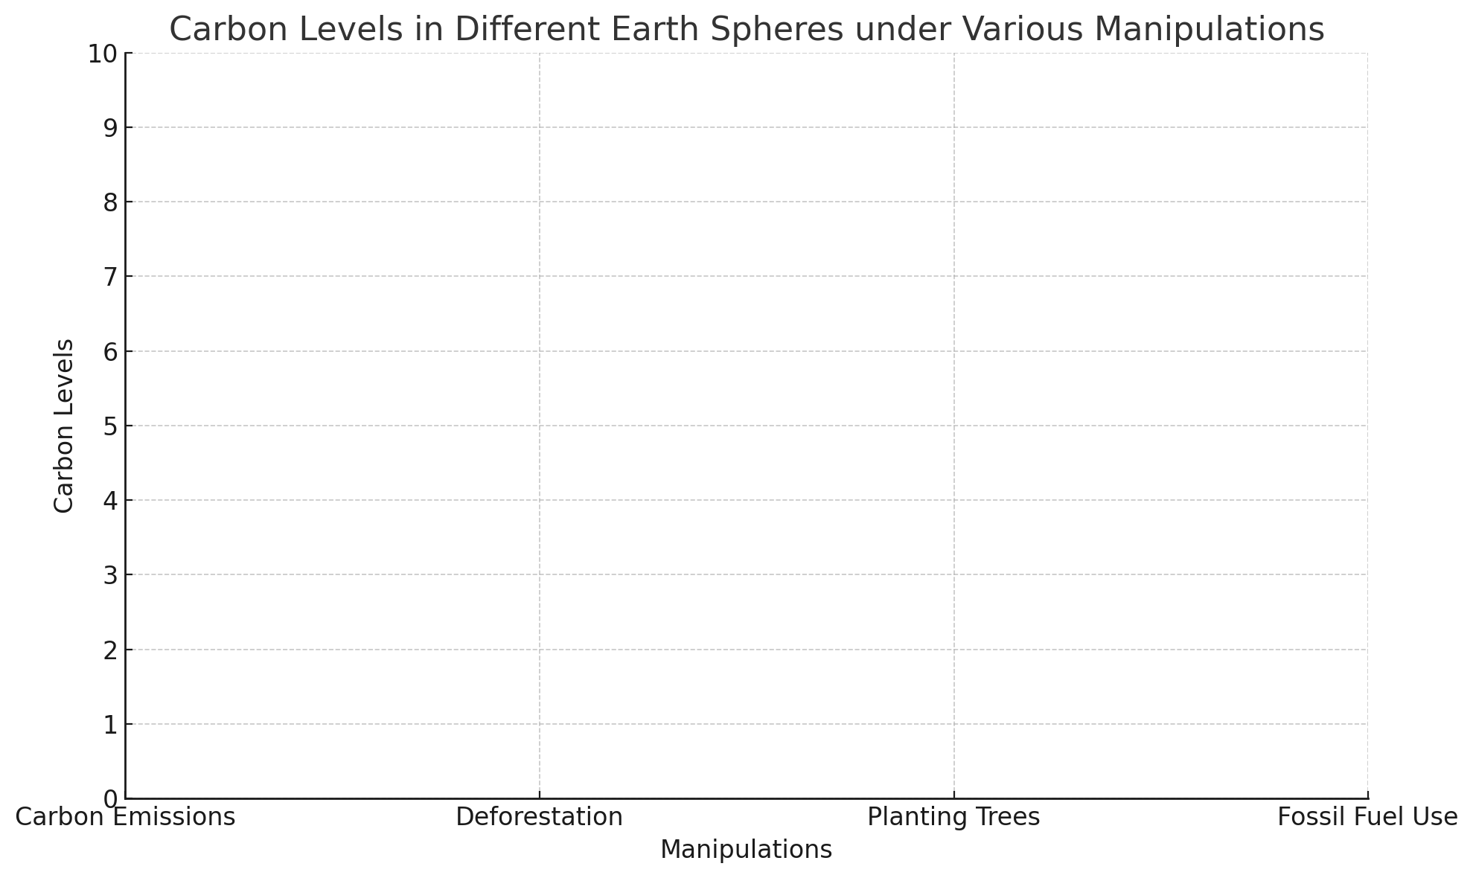
Lab Activity – Exploring the Carbon Cycle
CONCLUSION:
- Review your original hypotheses. Were they supported by your observations? Why or why not?

- Based on your observations, explain how changes in one part of the carbon cycle can affect other parts.

- How do human activities like burning fossil fuels and deforestation impact the carbon cycle?

- Suggest one way humans can help balance the carbon cycle.

- What is one thing you can do in your daily life to reduce your carbon footprint?

ANSWER KEY
Carbon Cycle – the process by which carbon moves through the atmosphere, hydrosphere, geosphere, and biosphere
Atmosphere – the layer of gases surrounding Earth, where carbon is found mainly in the form of carbon dioxide (CO₂)
Hydrosphere – all the water on Earth's surface, including oceans, lakes, rivers, and underground water, where carbon is dissolved as carbonates and bicarbonates
Geosphere – the solid part of Earth, including rocks and soil, where carbon is stored in fossil fuels, limestone, and other minerals
Biosphere – the global sum of all ecosystems, where carbon is found in living organisms, plants, animals, and microorganisms
Photosynthesis – the process by which plants and other organisms convert carbon dioxide and sunlight into oxygen and glucose, storing carbon in the biosphere
Respiration – the process by which living organisms convert oxygen and glucose into energy, releasing carbon dioxide back into the atmosphere
Fossil Fuels – natural fuels formed from the remains of ancient plants and animals, including coal, oil, and natural gas, which release carbon dioxide when burned
Deforestation – the removal of forests or trees, which reduces the biosphere's ability to absorb carbon dioxide and increases atmospheric carbon levels
Carbon Emissions – the release of carbon into the atmosphere, mainly as carbon dioxide, from activities such as burning fossil fuels, deforestation, and industrial processes
Greenhouse Gases – gases in Earth's atmosphere, including carbon dioxide, methane, and water vapor, that trap heat and contribute to the greenhouse effect
Greenhouse Effect – the process by which greenhouse gases trap heat in the atmosphere, leading to an increase in Earth's surface temperature
Carbon Sequestration – the process of capturing and storing atmospheric carbon dioxide in the geosphere, hydrosphere, or biosphere to mitigate climate change
Carbon Footprint – the total amount of carbon dioxide emissions for which an individual or organization is responsible, including emissions from transportation, energy use, and consumption of goods and services
Climate Change – Long-term changes in temperature, precipitation, and other atmospheric conditions on Earth, often linked to increased levels of greenhouse gases

HYPOTHESIS:
- Predict what will happen to the carbon levels in the atmosphere if carbon emissions increase.
Increasing carbon emissions will raise the carbon levels in the atmosphere.
- Predict how deforestation will affect the carbon levels in the biosphere and atmosphere.
Deforestation will increase carbon levels in the atmosphere and decrease carbon storage in the biosphere.
- Predict the impact of planting more trees on carbon levels in the atmosphere and biosphere.
Planting more trees will decrease carbon levels in the atmosphere and increase carbon storage in the biosphere.
- Predict how increasing the use of fossil fuels will change carbon levels across all spheres.
Increasing the use of fossil fuels will increase carbon levels in the atmosphere and reduce carbon stored in the geosphere.

IDENTIFYING COMPONENTS:
- Atmosphere
  - What is the role of the atmosphere in the carbon cycle?
The atmosphere contains carbon dioxide, which is a greenhouse gas.
  - List two ways carbon enters the atmosphere.
1. Respiration
2. Combustion of fossil fuels
- Hydrosphere
  - How does carbon move into the hydrosphere?
Carbon moves into the hydrosphere through the dissolution of carbon dioxide in water.
  - List one process that transfers carbon from the hydrosphere to another sphere.
Carbon is transferred from the hydrosphere to the atmosphere via processes such as outgassing and evaporation.
- Geosphere
  - Explain how carbon is stored in the geosphere.
Carbon is stored in the geosphere in the form of fossil fuels, limestone, and other carbon-containing minerals.
  - Name one way carbon is released from the geosphere.
Carbon is released from the geosphere through volcanic activity and the combustion of fossil fuels.
- Biosphere
  - Describe the role of the biosphere in the carbon cycle.
The biosphere involves living organisms that absorb and store carbon through photosynthesis.
  - Identify one way carbon is transferred from the biosphere to another sphere.
Carbon is transferred from the biosphere to the atmosphere through respiration and decomposition.

MANIPULATING VARIABLES:
- Increasing Carbon Emissions:
  - When carbon emissions are increased in the simulation, carbon levels in the atmosphere rise.
- Deforestation:
  - Deforestation decreases the amount of carbon stored in the biosphere and increases carbon levels in the atmosphere.
- Planting Trees:
  - Planting trees increases carbon storage in the biosphere and decreases carbon levels in the atmosphere.
- Fossil Fuel Use:
  - Increasing fossil fuel use raises carbon levels in the atmosphere and decreases carbon stored in the geosphere.

DATA COLLECTION AND ANALYSIS:
- Use the table below to record your observations for each manipulation.
Manipulation | Atmosphere | Hydrosphere | Geosphere | Biosphere
Carbon Emissions | Increases | Slight change | Decreases | Slight change
Deforestation | Increases | Slight change | Slight change | Decreases
Planting Trees | Decreases | Slight change | Slight change | Increases
Fossil Fuel Use | Increases | Slight change | Decreases | Slight change

Carbon Levels in Different Earth Spheres under Various Manipulations

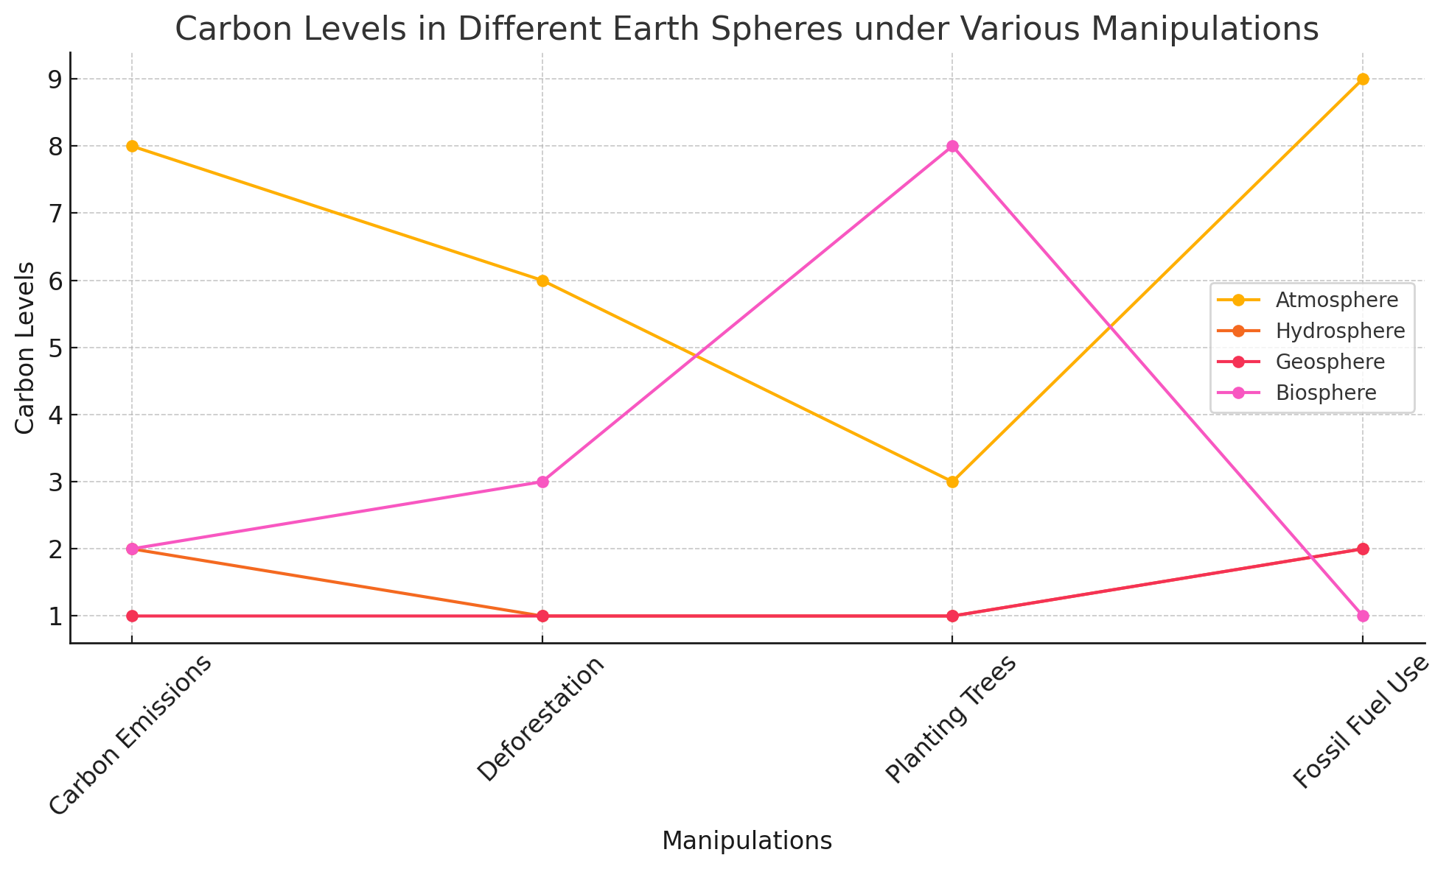

Name: Geologic History
Date: Period: Earth and Space Science
Worksheet – Understanding Carbon Cycle Processes
- Which of the following processes involves the removal of CO2 from the atmosphere by plants?

  - respiration
  - photosynthesis
  - combustion
  - decomposition

- Which Earth system acts as the largest reservoir for carbon?

  - atmosphere
  - biosphere
  - hydrosphere
  - geosphere

- During respiration, carbon is released back into the atmosphere in the form of:

  - methane
  - oxygen
  - carbon dioxide
  - carbon monoxide

- Which of the following is a significant source of carbon emissions due to human activity?

  - photosynthesis
  - volcanic eruptions
  - fossil fuel combustion
  - ocean absorption

- What is the primary process that transfers carbon from the atmosphere to the oceans?

  - photosynthesis
  - diffusion
  - respiration
  - combustion

- Carbon is stored in the soil primarily through

  - respiration
  - photosynthesis
  - decomposition
  - combustion

- Which process is responsible for the release of carbon dioxide during the burning of fossil fuels?

  - photosynthesis
  - respiration
  - decomposition
  - combustion

- Which process involves the conversion of carbon dioxide and water into glucose and oxygen?

  - respiration
  - photosynthesis
  - combustion
  - decomposition

- Which of the following components is part of the geosphere in the carbon cycle?

  - oceans
  - fossil fuels
  - plants
  - animals

- Increased atmospheric CO₂ levels are most closely linked to

  - global cooling
  - global warming
  - decreased plant growth
  - ocean acidification

Name: Geologic History
Date: Period: Earth and Space Science
Worksheet – Carbon Reservoirs and Transfers
- Which process involves the release of carbon dioxide from the soil?

  - photosynthesis
  - respiration
  - decomposition
  - combustion

- What is the role of decomposers in the carbon cycle?
  - to convert CO₂ to oxygen
  - to release carbon from dead organisms into the soil
  - to absorb CO₂ from the atmosphere
  - to store carbon in the geosphere

- Which of the following processes moves carbon from the biosphere to the atmosphere?

  - photosynthesis
  - respiration
  - diffusion
  - sedimentation

- In the carbon cycle, which process is responsible for the formation of fossil fuels?

  - respiration
  - photosynthesis
  - decomposition
  - sedimentation

- The exchange of carbon between the atmosphere and the oceans is primarily driven by:

  - photosynthesis and respiration
  - diffusion
  - combustion and respiration
  - photosynthesis and combustion

- What is the main effect of deforestation on the carbon cycle?
  - Increase in carbon storage in the biosphere
  - Decrease in atmospheric carbon dioxide
  - Increase in atmospheric carbon dioxide
  - Decrease in carbon storage in the geosphere

Worksheet – Carbon Reservoirs and Transfers
- Which of the following best describes the role of the ocean in the carbon cycle?
  - It is a minor carbon sink.
  - It only releases carbon dioxide.
  - It absorbs and stores large amounts of carbon dioxide.
  - It does not participate in the carbon cycle.

- Which process adds carbon to the soil?
  - combustion
  - photosynthesis
  - decomposition
  - respiration

- The process of carbon dioxide being absorbed by ocean water is called:
  - diffusion
  - respiration
  - photosynthesis
  - combustion

- What happens to carbon in the process of photosynthesis?
  - It is converted into glucose and oxygen.
  - It is released into the atmosphere.
  - It is stored as fossil fuels.
  - It is converted into methane and water.

KEY – UNDERSTANDING CARBON CYCLE PROCESSES

- B
- D
- C
- C
- B
- C
- D
- B
- B
- B

KEY – CARBON RESERVOIRS AND TRANSFERS

- C
- B
- B
- D
- B
- C
- C
- C
- A
- A

Name: Geologic History
Date: Period: Earth and Space Science
Assessment – The Carbon Cycle
- Which of the following is the largest carbon reservoir?

  - atmosphere
  - oceans
  - soil
  - biosphere

- Photosynthesis primarily involves the movement of carbon from

  - soil to plants
  - atmosphere to plants
  - oceans to atmosphere
  - plants to atmosphere

- Which process releases carbon dioxide back into the atmosphere?

  - photosynthesis
  - respiration
  - combustion
  - both B and C

- What role do decomposers play in the carbon cycle?
  - They remove carbon from the soil.
  - They convert organic carbon to carbon dioxide.
  - They store carbon in the biosphere.
  - They convert carbon dioxide to organic carbon.

- Which human activity is a major source of carbon dioxide emissions?

  - reforestation
  - burning fossil fuels
  - planting trees
  - ocean acidification

- Carbonate rocks store carbon in which form?

  - organic carbon
  - inorganic carbon
  - methane
  - carbon dioxide

- The process of carbon dioxide being absorbed by ocean water is called

  - photosynthesis
  - diffusion
  - combustion
  - respiration

- In the carbon cycle, what is the primary way that carbon moves from the atmosphere to the ocean?

  - photosynthesis
  - respiration
  - diffusion
  - combustion

- Which process is primarily responsible for the carbon exchange between the soil and the atmosphere?

  - respiration
  - photosynthesis
  - decomposition
  - combustion

Assessment – The Carbon Cycle
- Which of the following best describes the carbon cycle?

  - a linear process
  - a closed loop
  - an open loop
  - a random process

- The carbon in fossil fuels originally came from:

  - decomposed plants and animals
  - volcanic eruptions
  - atmospheric CO₂
  - ocean sediments

- What is the primary way that carbon is stored in the geosphere?

  - as methane gas
  - in carbonate rocks
  - in living organisms
  - as carbon dioxide

- Which of the following processes converts organic carbon into atmospheric carbon dioxide?

  - photosynthesis
  - respiration
  - sedimentation
  - assimilation

- Which is not a significant carbon sink?

  - forests
  - oceans
  - atmosphere
  - soil

- Increased levels of atmospheric CO₂ are most closely associated with:
  - Increased ocean acidity
  - Decreased global temperatures
  - Increased volcanic activity
  - Decreased plant growth

- What is the main effect of deforestation on the carbon cycle?
  - Decrease in carbon storage in the biosphere
  - Increase in carbon storage in the geosphere
  - Increase in atmospheric carbon dioxide
  - Both A and C

- Which process is not involved in the short-term carbon cycle?

  - photosynthesis
  - combustion of fossil fuels
  - respiration
  - formation of fossil fuels

- Which process primarily adds carbon to the soil?

  - photosynthesis
  - respiration
  - decomposition
  - combustion

Assessment – The Carbon Cycle
- Which of the following is an example of a carbon source?

  - Growing forest
  - Dying forest
  - Limestone formation
  - Ocean uptake of CO₂

- Which of the following best describes the relationship between photosynthesis and respiration in the carbon cycle?
  - Photosynthesis releases CO₂; respiration absorbs CO₂
  - Photosynthesis and respiration both absorb CO₂
  - Photosynthesis absorbs CO₂; respiration releases CO₂
  - Photosynthesis and respiration both release CO₂

- The following data table shows carbon dioxide emissions from different sources over a decade.
Year | Fossil Fuels (Gt) | Deforestation (Gt) | Respiration (Gt) | Oceans (Gt)
2010 | 7.0 | 1.5 | 60.0 | 90.0
2020 | 9.0 | 2.0 | 62.0 | 92.0

Analyze the trends in carbon emissions from fossil fuels and deforestation over the decade. What can you infer about their impact on atmospheric CO₂ levels?

- Examine the carbon cycle diagram provided below.
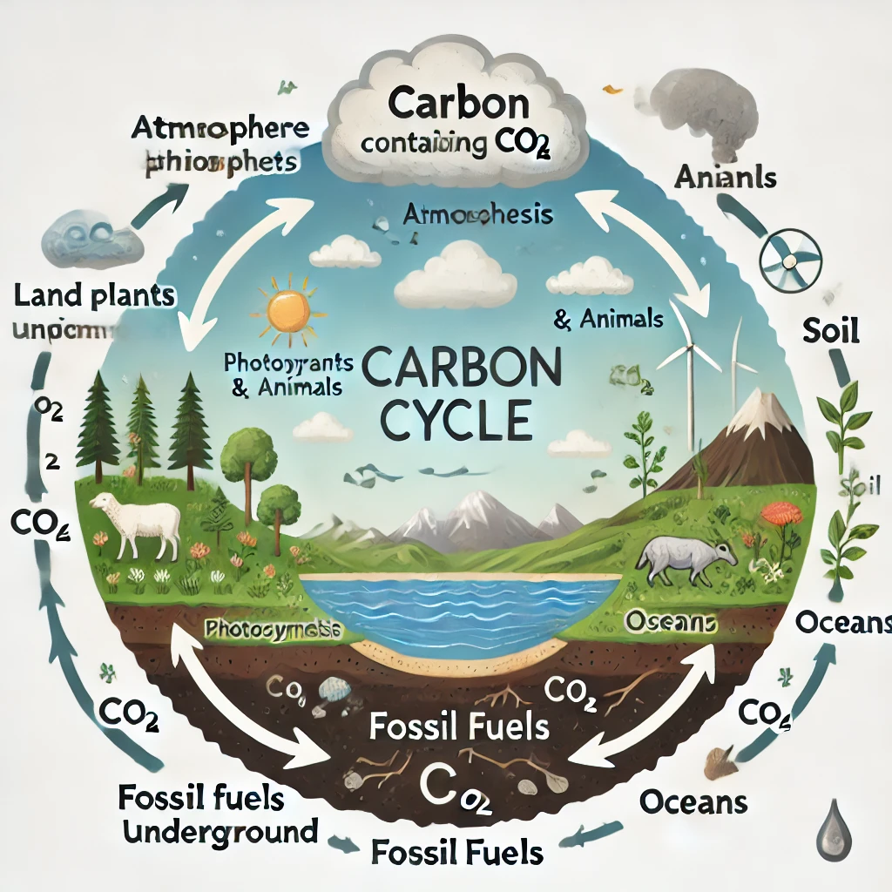
Identify and describe two processes that transfer carbon from the atmosphere to the biosphere. Explain their significance in the carbon cycle.
Assessment – The Carbon Cycle
- Review the following graph showing changes in atmospheric CO₂ levels and global temperature anomalies from 1950 to 2020.
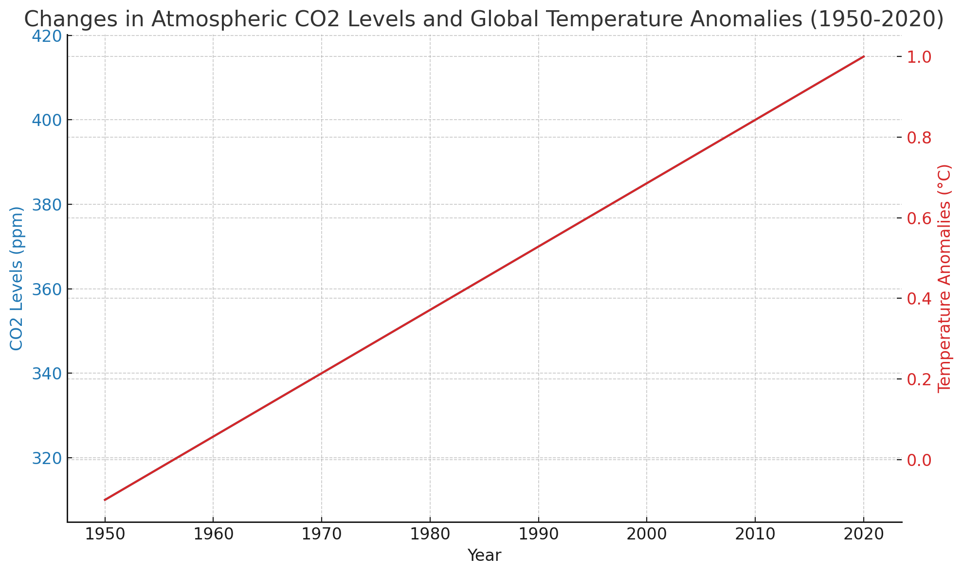
How do changes in atmospheric CO₂ levels correlate with global temperature anomalies? Provide a brief explanation based on the data.

- Consider the role of phytoplankton in the carbon cycle. Describe how phytoplankton contribute to the carbon cycle in the oceans. What might happen to the carbon cycle if phytoplankton populations declined significantly?

- A case study indicates a significant increase in volcanic activity, releasing large amounts of CO₂. Discuss the potential short-term and long-term impacts of increased volcanic CO₂ emissions on the carbon cycle and Earth's climate.

Name: Geologic History
Date: Period: Earth and Space Science
ANSWER BOOKLET – Assessment – The Carbon Cycle

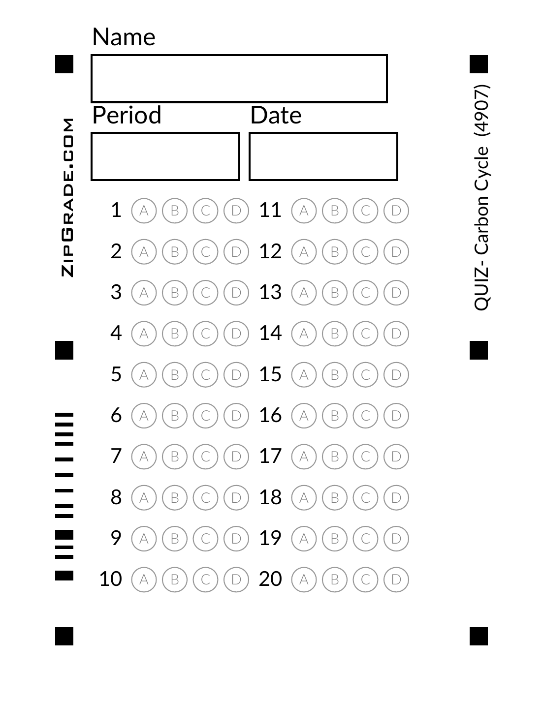

ANSWER BOOKLET – Assessment – The Carbon Cycle

21.

22. Process 1:
Significance:
Process 2:
Significance:

23.

24.

25. Short-term Impacts:

Long-term Impacts:

Assessment – The Carbon Cycle

KEY

- B
- B
- D
- B
- B
- B
- B
- C
- C
- B
- A
- B
- B
- C
- A
- D
- D
- C
- B
- C

- Over the decade, fossil fuel emissions increased from 7.0 Gt to 9.0 Gt, and deforestation emissions increased from 1.5 Gt to 2.0 Gt. This suggests a growing contribution of these sources to atmospheric CO₂ levels, likely leading to higher concentrations of atmospheric CO₂ and enhanced greenhouse effect.
- Two processes are photosynthesis and diffusion into the oceans. Photosynthesis by plants absorbs CO₂ from the atmosphere, converting it into organic matter. Diffusion transfers CO₂ from the atmosphere to the ocean surface, where it is used by marine organisms or stored as dissolved inorganic carbon.
- The data likely show a positive correlation between atmospheric CO₂ levels and global temperature anomalies, indicating that as CO₂ levels rise, global temperatures also tend to increase due to the enhanced greenhouse effect.
- Phytoplankton absorb CO₂ during photosynthesis, converting it into organic matter and forming the base of the marine food web. If phytoplankton populations declined, there would be less CO₂ absorption, potentially increasing atmospheric CO₂ levels and affecting marine ecosystems.
- Short-term: Increased volcanic CO₂ emissions could temporarily boost atmospheric CO₂ levels, potentially leading to short-term warming.
Long-term: Over time, increased CO₂ could enhance the greenhouse effect, leading to long-term climate changes such as global warming, altered weather patterns, and impacts on ecosystems and human societies.

ANSWER KEY
Carbon Cycle – the process by which carbon moves through the atmosphere, hydrosphere, geosphere, and biosphere
Atmosphere – the layer of gases surrounding Earth, where carbon is found mainly in the form of carbon dioxide (CO₂)
Hydrosphere – all the water on Earth's surface, including oceans, lakes, rivers, and underground water, where carbon is dissolved as carbonates and bicarbonates
Geosphere – the solid part of Earth, including rocks and soil, where carbon is stored in fossil fuels, limestone, and other minerals
Biosphere – the global sum of all ecosystems, where carbon is found in living organisms, plants, animals, and microorganisms
Photosynthesis – the process by which plants and other organisms convert carbon dioxide and sunlight into oxygen and glucose, storing carbon in the biosphere
Respiration – the process by which living organisms convert oxygen and glucose into energy, releasing carbon dioxide back into the atmosphere
Fossil Fuels – natural fuels formed from the remains of ancient plants and animals, including coal, oil, and natural gas, which release carbon dioxide when burned
Deforestation – the removal of forests or trees, which reduces the biosphere's ability to absorb carbon dioxide and increases atmospheric carbon levels
Carbon Emissions – the release of carbon into the atmosphere, mainly as carbon dioxide, from activities such as burning fossil fuels, deforestation, and industrial processes
Greenhouse Gases – gases in Earth's atmosphere, including carbon dioxide, methane, and water vapor, that trap heat and contribute to the greenhouse effect
Greenhouse Effect – the process by which greenhouse gases trap heat in the atmosphere, leading to an increase in Earth's surface temperature
Carbon Sequestration – the process of capturing and storing atmospheric carbon dioxide in the geosphere, hydrosphere, or biosphere to mitigate climate change
Carbon Footprint – the total amount of carbon dioxide emissions for which an individual or organization is responsible, including emissions from transportation, energy use, and consumption of goods and services
Climate Change – Long-term changes in temperature, precipitation, and other atmospheric conditions on Earth, often linked to increased levels of greenhouse gases

